9th Grade Stream B
Passover English Assignments

Passover is just around the corner and here is a grammar exercise.

lease notice: the answers must be sent to your teacher via webtop by the 17th of April.
שימו לב: את עבודתכם יש לשלוח למורה שלכם דרך וובטופ בקובץ וורד עד ל-17 באפריל.

Good luck and keep safe!

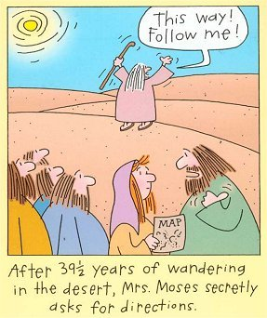
Tense Review Exercise:
Fill in the verbs in the correct forms of the Present Simple or the
Past Simple:
1. Last summer we (go)_____________ to a camping site near the sea.
We all (have) ______________ a wonderful time there.
2. Dan usually (eat) _______________ dinner at about 5.00 in the afternoon.
What time (you/eat) ___________________ dinner?
3. Our teacher never (forget) _________________ to give us homework.
4. Last year my family (drive) _______________ from New York to
Los Angeles.
5. They (not feed) ________________ the animals in the evenings.
6." (you/fly) ______________________ to New York last week?"
" No, I (fly) _________________ to New York last month."
7. We (hear) _________________ the good news a few minutes ago.
8." (you/find) ___________________ the key you lost yesterday?"
" Yes, I (find) __________________ it in the washing machine
a few minutes ago."
9. My brother (not get) _________________ a lot of e. mail messages
every day, but he (get) _______________ ten messages yesterday.
10. Moti (not feel) __________________ well last night.

